Laxmi Charitable Trust’s
Sheth L.U.J College of Arts & Sir M.V. College of Science and Commerce Department of Information Technology (B.Sc.I.T Semester V)
Artificial Intelligence Application Development Module 1
Practical 8
Roll no. : T022 | Name : Pratik Mishra
Class : TYIT | Batch : 1
Date of assignment : 22/08/2026 | Date of assignment : 22/08/2026

Ethics and Bias Analysis
Select any publicly available dataset (for example, Iris, Adult Income, or a classification dataset of your choice) and analyze it for possible bias and class imbalance.
Using titanic dataset: Code:
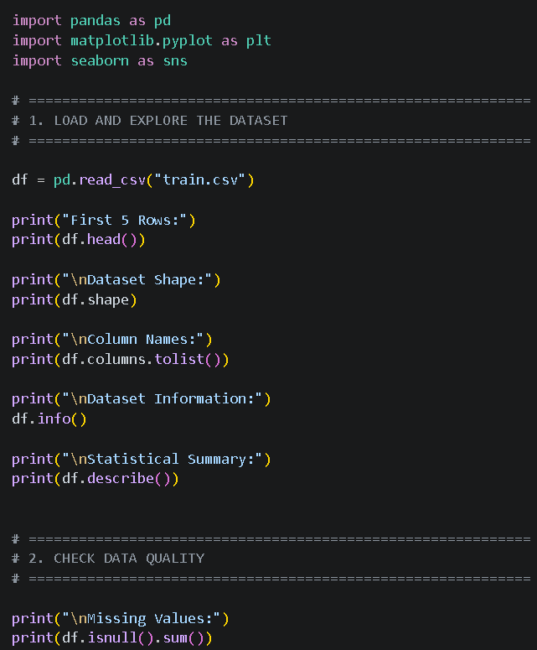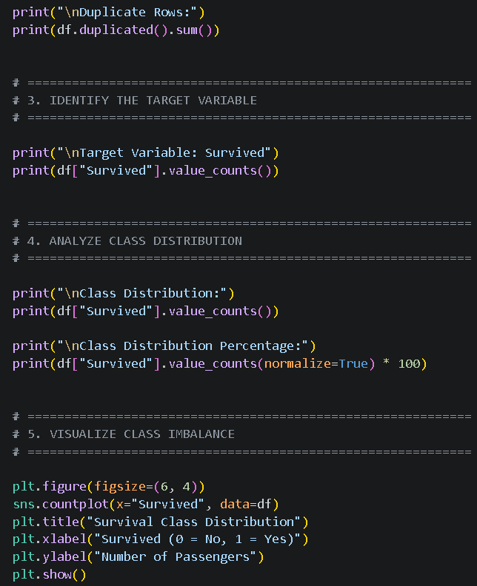
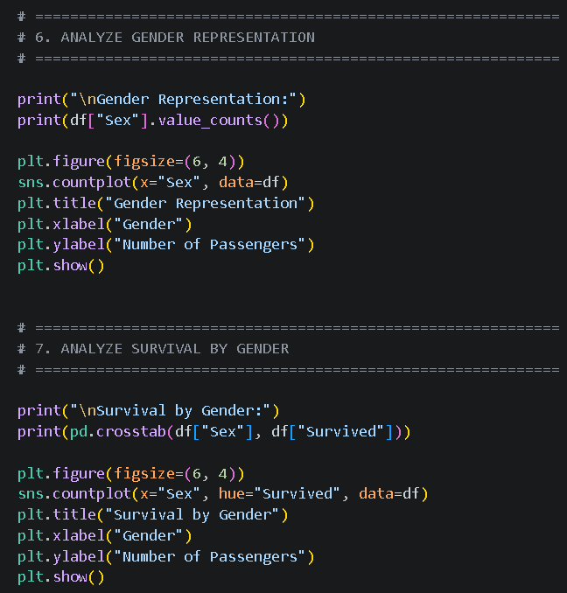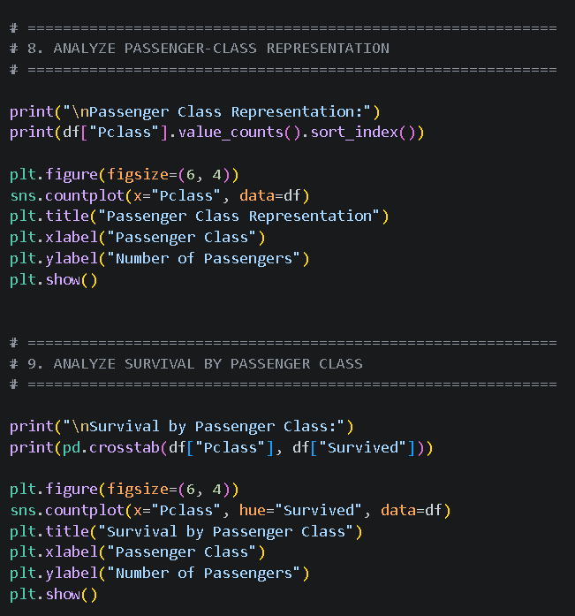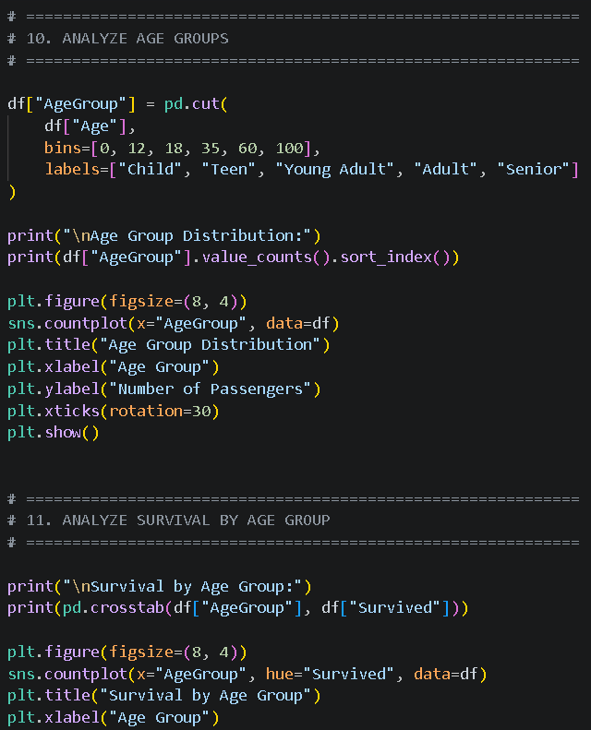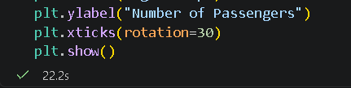

Output:
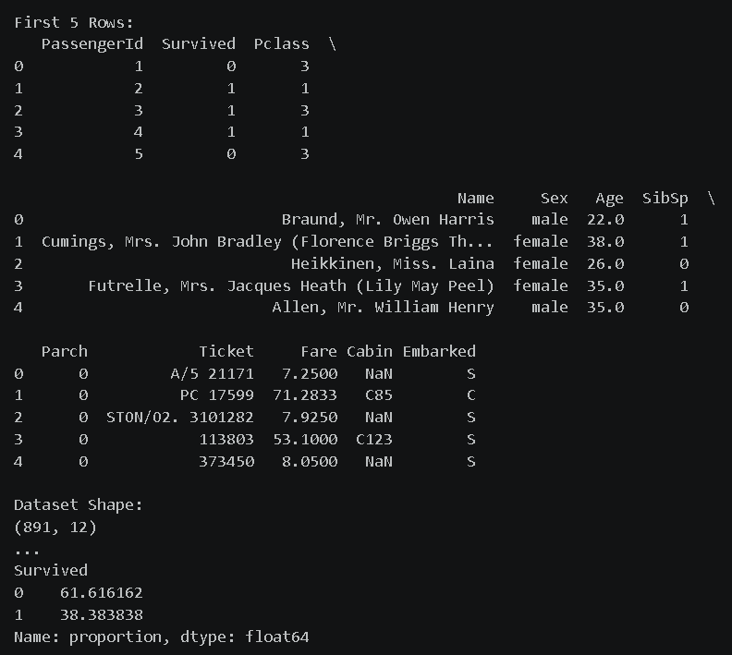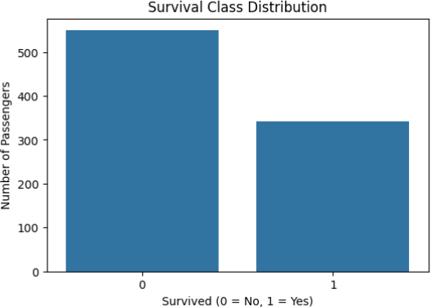
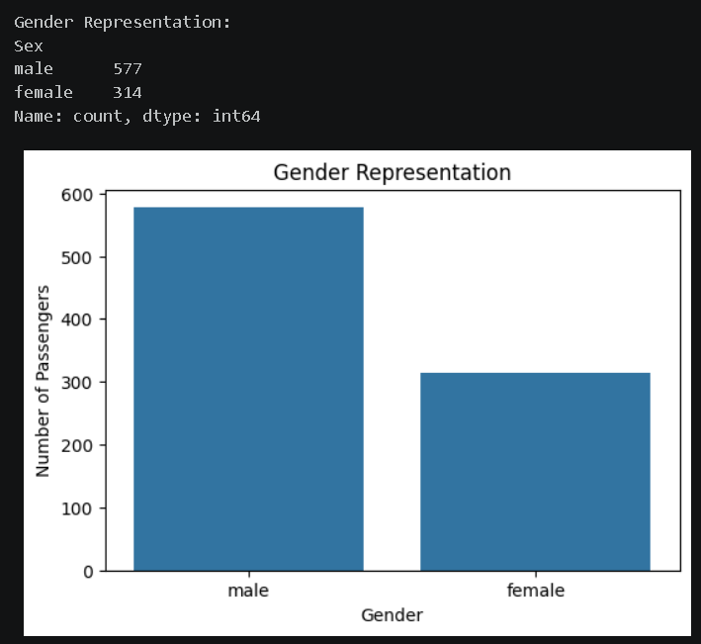
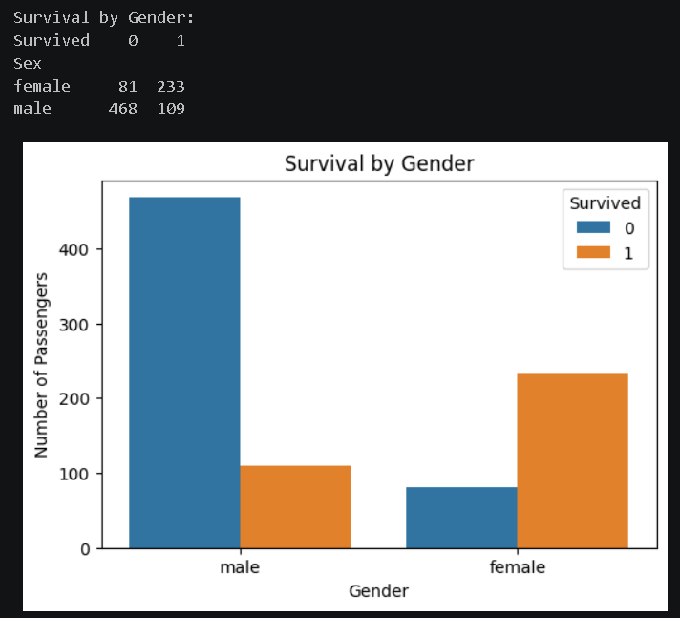
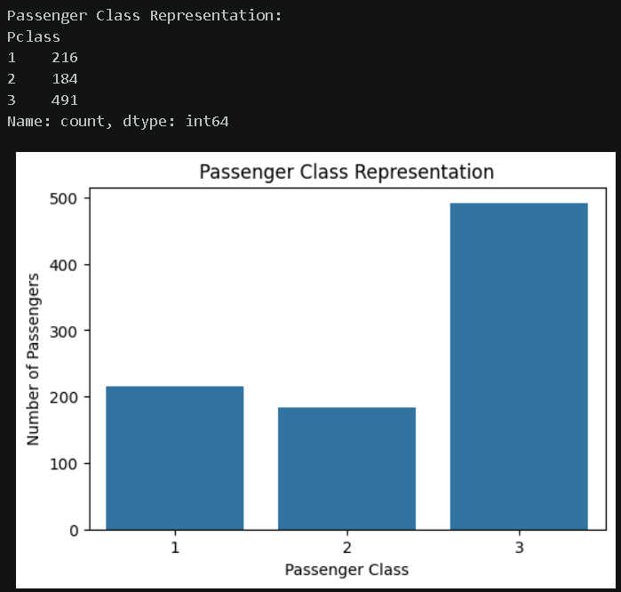

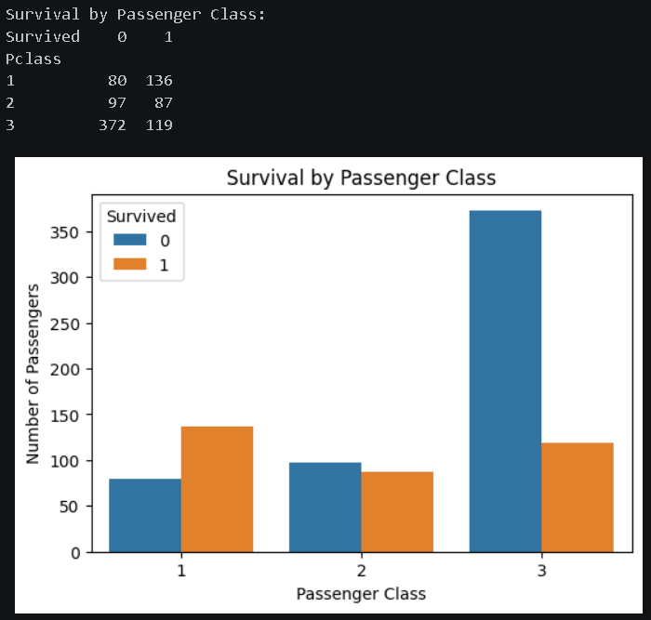
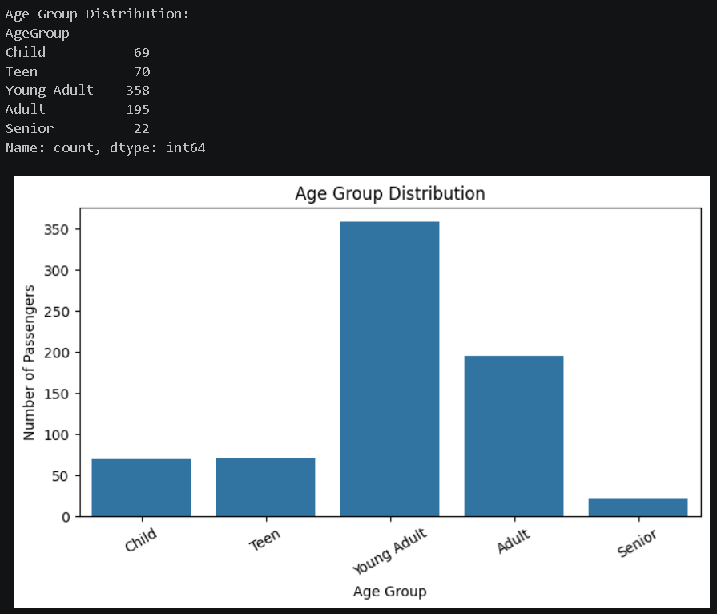
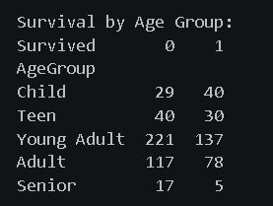

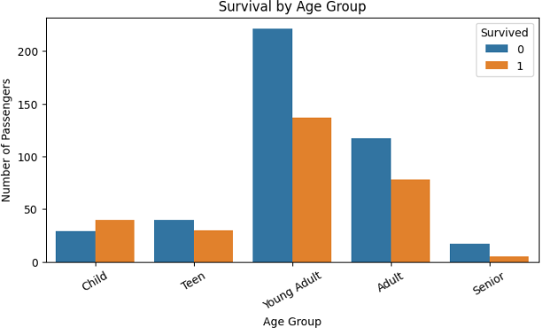

Impact on ML
The identified biases can affect machine-learning models by causing the model to rely
heavily on features such as gender, passenger class, and age. This may result in less accurate or unfair predictions for certain groups. Missing values can also reduce model performance and introduce additional bias.

Suggested Solutions
  - Handle missing values properly.
  - Use suitable techniques to fill missing Age values.
  - Check and address class imbalance.
  - Use stratified train-test splitting.
  - Evaluate model performance separately for different gender and age groups.
  - Use fairness metrics along with accuracy.
  - Avoid unnecessary features that may introduce unfair bias.

Final Conclusion
The Titanic dataset contains class imbalance and noticeable differences in survival based on gender, passenger class, and age. These differences may introduce bias into machine-learning models. Therefore, proper data preprocessing, imbalance handling, and fairness evaluation
are important for developing reliable and fair ML models.

Using german_credit_data.csv Code:
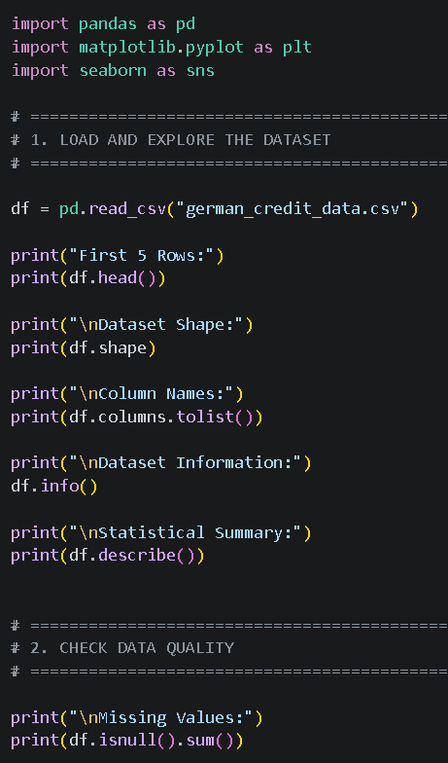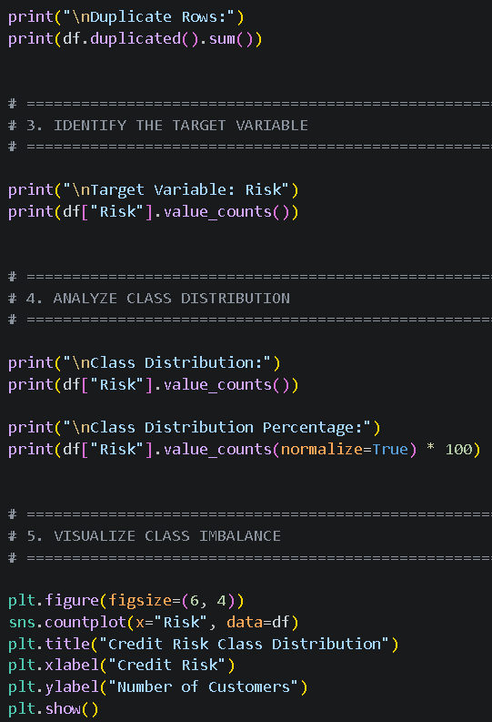
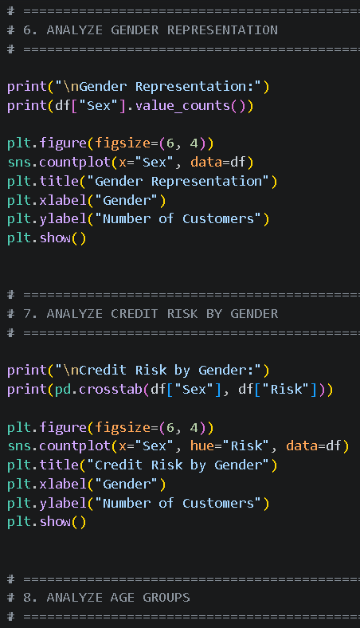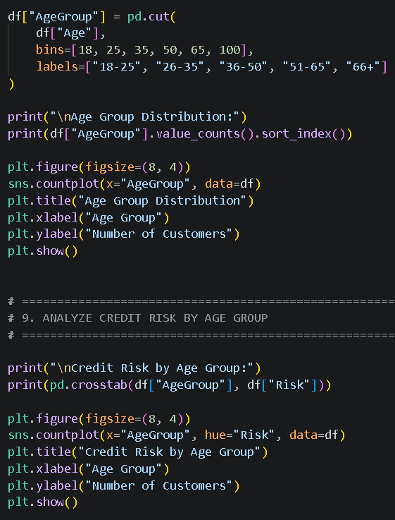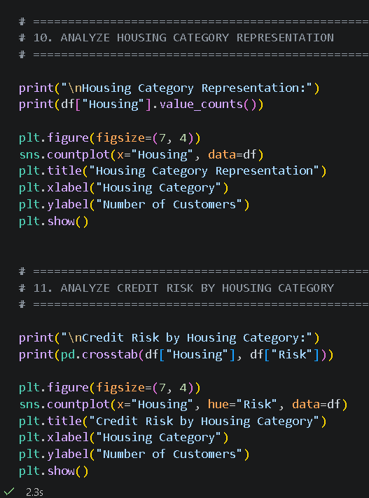

Output:
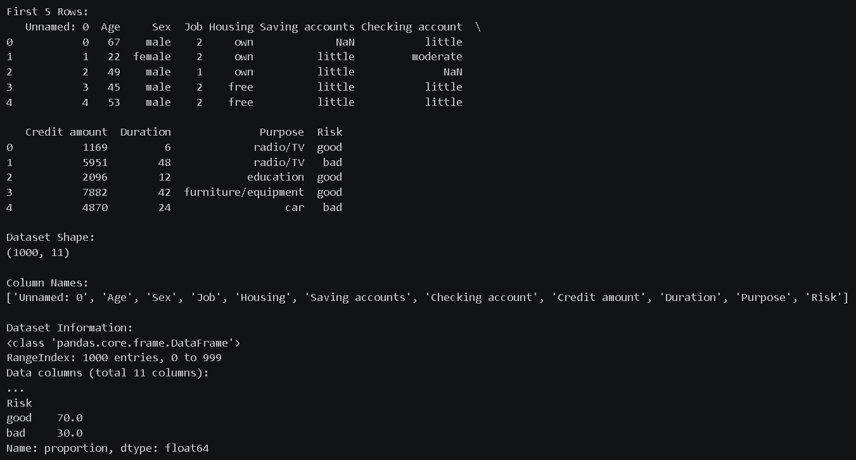
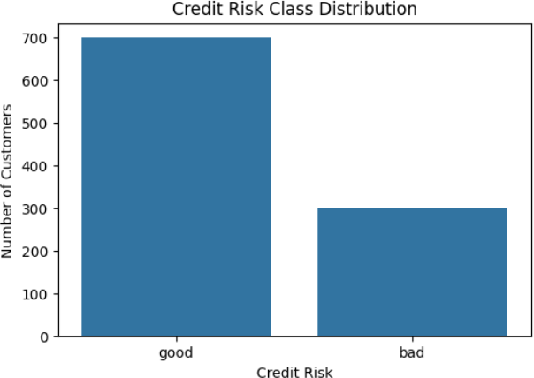
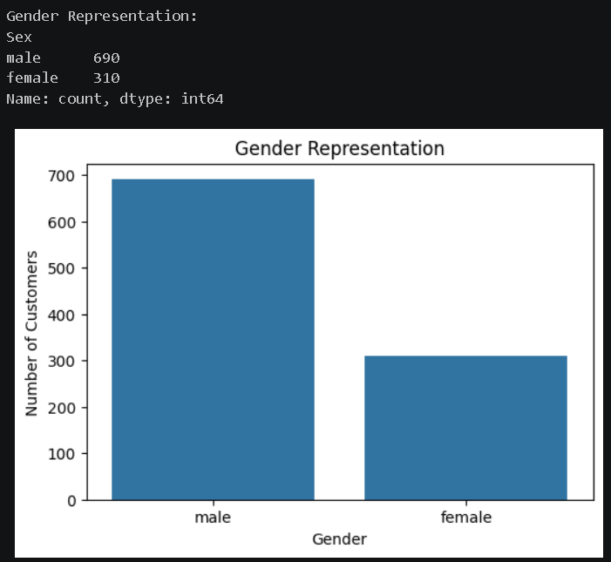

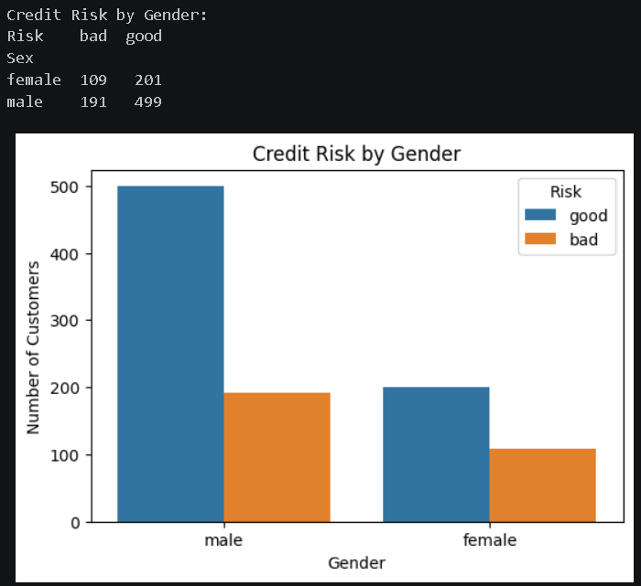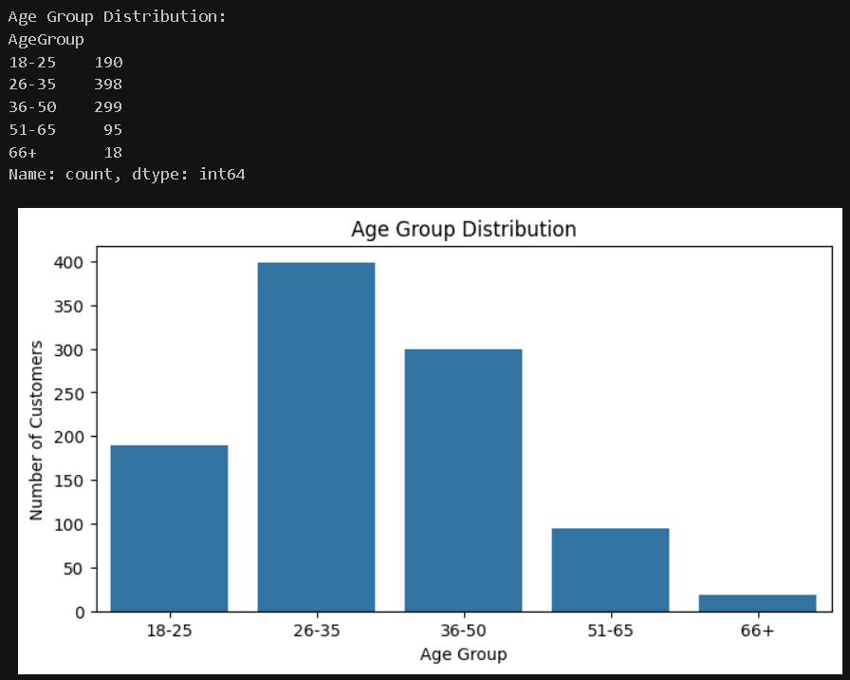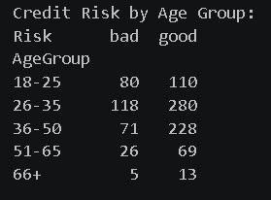
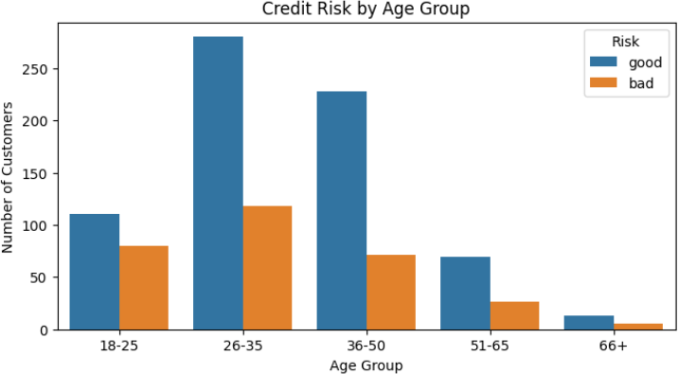
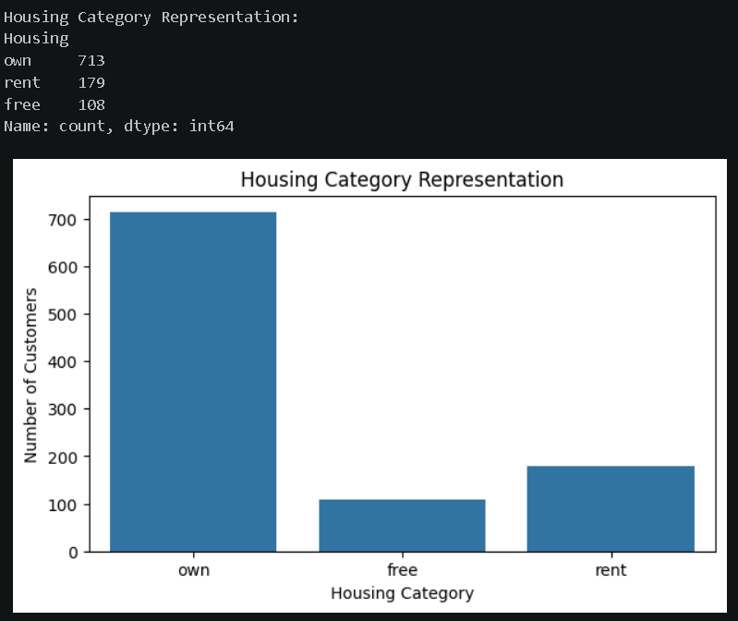
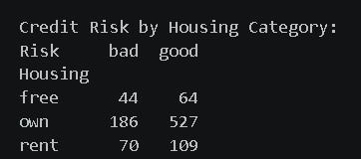
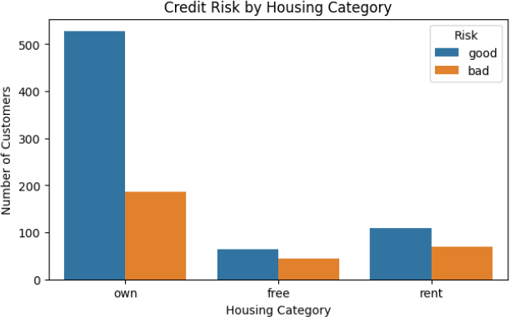

Identify Possible Bias
  - Gender Bias: Survival rates were significantly different between males and females.
  - Passenger Class Bias: First-class passengers had better survival chances than lower-class passengers.
  - Age Bias: Different age groups had different survival rates.
  - Missing Data Bias: Missing values, especially in Age and Cabin, can affect the analysis.
  - Historical Bias: The dataset represents a specific historical event and may not represent the general population.

Impact on ML
Bias in the German Credit Risk dataset can cause a machine-learning model to make unfair credit-risk predictions for certain groups. Gender, age, and housing characteristics may
influence the model's decisions. Class imbalance can also cause the model to perform better for the majority risk class than the minority class.

Suggested Solutions
  - Handle missing values appropriately.
  - Check and address class imbalance.
  - Use stratified sampling during train-test splitting.
  - Evaluate accuracy, precision, recall, and F1-score.
  - Compare model performance across gender and age groups.
  - Use fairness metrics to identify unequal outcomes.
  - Avoid unnecessary sensitive attributes when appropriate.
  - Regularly monitor the model for biased predictions.

Final Conclusion
The German Credit Risk dataset can contain potential bias related to gender, age, housing category, and class distribution. These biases may affect the fairness and reliability of
machine-learning predictions. Proper preprocessing, class-balancing techniques, group-wise evaluation, and fairness analysis can help develop a more reliable and responsible credit-risk model.

